Town Plan

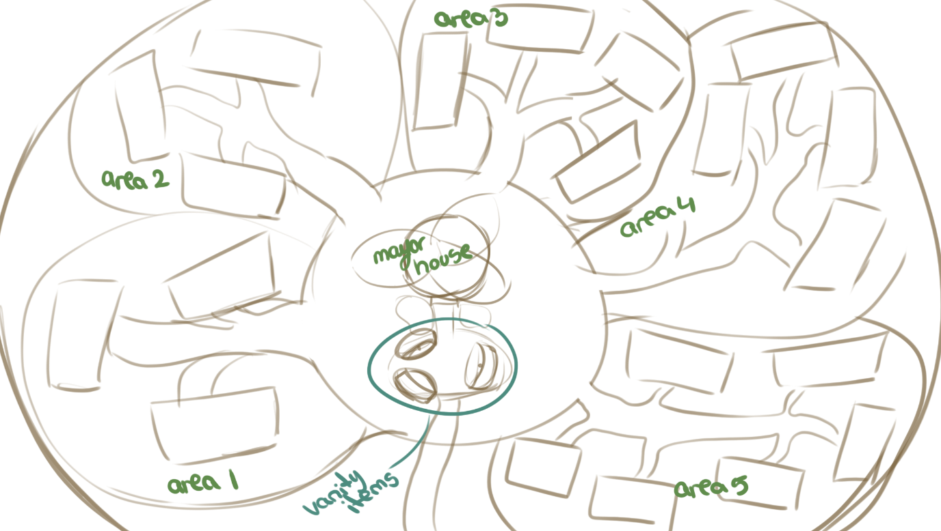

The main Area is in the middle, the Mayor’s house and the park in front of it, the whole plaza could have vanity items in it.

I thought that it would be better if there are roads connecting all the factories in one area, and the areas can unlock clockwise, getting more complicated as the player progresses.

Each rectangle represents a factory on the map.

I was also thinking that the map should be limited and closed in a smaller boundary to show it is inside a tree, that’s why the map is round shaped.